Nicole Pirri
Period 7
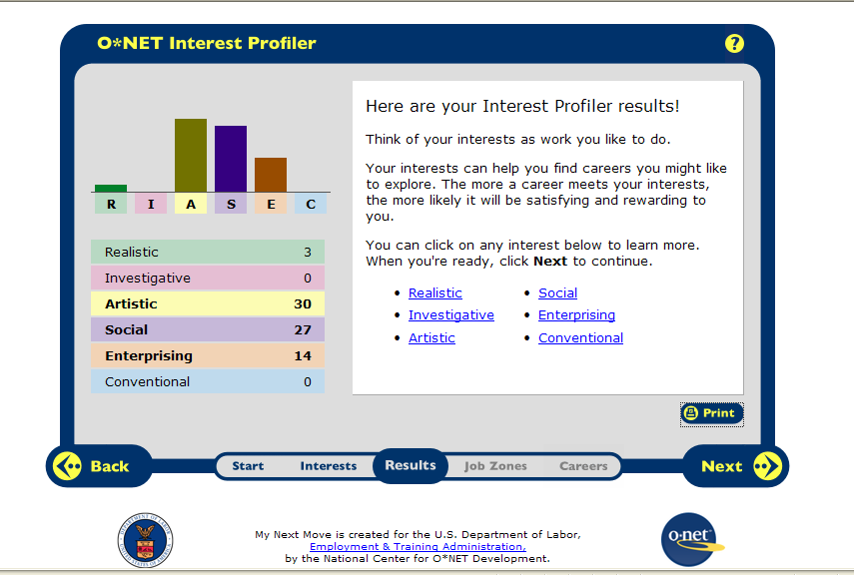

I think the Artistic interest category fits me because I am always interested in design and I enjoy doing creative work.
I also think Social interests fits because I always wanted a rewarding career where I am helping people and I always wanted to be a teacher.

- Dietitian/nutritionist
- Secondary school teacher
- Poet/lyricist
- Translator/interpreter
- Director
- Mental health counselor
- Editorial writer

HR1. What is the definition of each occupation that your group has chosen and the nature of the work?
Dietitian: plan food/nutrition programs
Secondary teacher: teach students one or more subjects in a public/private school setting
Poet/lyricist: songwriters produce content for radio and television broadcasts
Interpreter: sign-language interpreters convert between spoken communication and sign language
Director: express ideas and create images in theater, film, radio, television, and other performing arts media.
Mental health counselor: work with individuals, families, and groups to address and treat mental and emotional disorders and to promote mental health.
Editorial writer: editors use desktop or electronic publishing software, scanners, and other electronic communications equipment. many writers today prepare material directly for the Internet, such as online newspapers and text for video games, they should be knowledgeable about graphic design, page layout, and multimedia software. should be familiar with interactive technologies of the Web so that they can blend text, graphics, and sound together
HR2. What are some of the related occupational fields?
Dietitian: health educators, food service managers.
Secondary teacher: librarians, counselors.
Poet/lyricist: announcers, interpreters/translators
Interpreter: teacher, court reporter
Director: dancer, musician, makeup artist
Mental health counselor: human resources, occupational therapist, physician.
Editorial writer: announcers, interpreters/translators
HR3. Which personality type(s) is best suited to the occupations/jobs you have researched?
Dietitian: social
Secondary teacher: social
Poet/lyricist: artistic
Interpreter: social
Director: artistic
Mental health counselor: social
Editorial writer: artistic
HR4. What kind of education, training and qualifications are required?
Dietitian: bachelor’s degree in foods and nutrition or related field
Secondary teacher: a bachelors degree
Poet/lyricist: degree in communications, journalism, english
Interpreter: specialized training, knowing at least 2 languages is essential, bachelor’s degree, a degree in translation studies. Certification for sign interpreters
Director: bachelor degree recommended but not always necessary
Mental health counselor: masters degree, state licensure and certification

HR5. What technology skills are needed to be successful in the career/occupational fields you have explored?
Dietitian: suggested courses are computer science and communications
Secondary teacher: teacher education programs require classes in the use of computers and other technologies.
Poet/lyricist: new demand for writers and editors with Web or multimedia experience.
Interpreter: take courses in basic computer proficiency
Director: take courses in radio/television broadcasting and communications
Mental health counselor: not specifically

RC1. What does each occupation pay, or what are the average earnings nationally and in this area of the country?
Dietitian: $52,000 a year
Secondary teacher: $35,000-$40,000
Poet/lyricist: freelance writers earn money from their publications on an individual basis and usually support themselves from another source.
Interpreter: $38,000
Director: $65,000
Mental health counselor: $45,000
Editorial writer: $53,070
RC2. What is the projected growth for this career field over the next 10 years? (i.e. will there be more or less jobs like this in the future?)
Dietitian: 6,000 more jobs 20%
Secondary teacher: to increase 9%
Poet/lyricist: increase 15%
Interpreter: 22% increase
Director: 11%
Mental health counselor: 24% increase
RC3. Please identify local or national organizations that would hire someone in each career field you have explored.
Dietitian: hospitals, clinics, care centers
Secondary teacher: public and private schools
Poet/lyricist: freelance writers work for themselves.
Interpreter: hospitals, schools
Director: motion picture/performing arts industry
Mental health counselor: doctor’s office, outpatient care center

ISC1. What are the working conditions or work environment for each job you or your group decided to research (such as work schedule, hours, exempt/salaried or non-exempt/hourly, etc.)?
Dietitian: usually work in clean well lighted and well ventilated areas. Some can work in hot congested kitchens. Standard 40-hour week, sometimes weekends.
Director: work under constant pressure, need patience and commitment. Work hours are long and unpredictable
Secondary teacher: in a classroom setting. Work is stressful due to misbehaving students, work load, and lack of amenities. These aspects aren’t as big a problem in private schools. More than 40 hours a week.
Poet/lyricist: freelance writers enjoy running their own business and having flexible hours, but stressed by juggling multiple projects or need for new work. use of computers for extended periods may cause some individuals to experience back pain, eyestrain, or fatigue.
Interpreter: technology allows translators to work anywhere and a lot work from home
Mental health counselor: many counselors work in an office where they see clients throughout the day

ISC2. Are positions in this career field typically part of collective bargaining units (unions)?
dietitian: depends on where you work
Secondary teacher: they are part of a union
Poet/lyricist: are not part of a union
Interpreter: no
Director: no
Mental health counselor: yes

ISC3. What kind of opportunities for advancement are there for each career? (i.e. Is there a chance to get promoted, etc.?)
Dietitian: there is chance for promotion and their more training, degrees, experience you have the more money you will make and better position you will get
Secondary teacher: national certification can boost salary. Can also become administrators or supervisors
Poet/lyricist: getting published in prestigious places, and building a reputation
Interpreter: after gaining sufficient experience , they may move up to more difficult assignments or eventually manage a translation agency
Director: reputation grows, work on bigger budget productions
Mental health counselor: advance with further education
I narrowed down my career choices by thinking of which ones were more logical and achievable. Also, I took into consideration which jobs would be enjoyable and help me gain good revenue. I chose careers I thought would provide me happiness and support for myself and a future family.

